**1.PROJECT TITLE : HIGH-QUALITY FACE RECOGNITION SYSTEM**

**2.INTRODUCTION**

**2.1 OVERVIEW**

Recently Face-recognition system is attracting a much attention in the society of multimedia information access. Areas such as network security, video compression benefits from face-recognition.In this project we’ll build a Facial Recognization application that can detect faces and recognize them. We are going to build this using dlib which uses 128 point face detectors which outputs these 128 points fro all the face and compares them with existing faces.This project has two phases, to implement the detection of faces and to recognize the faces.

**2.2 PURPOSE**

This facial recognition not only improves the user-friendliness, but also makes hackers virtually impossible to steal the users files and information. It can compare the information with the database of known faces to find a match. More importantly it increases privacy issues. Over 160 **c**ountries around the world are using this face recognition system.

**3.OUTPUT:**



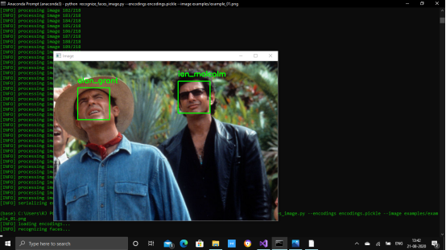

**4.APPLICATIONS:**

1. Payments
2. Access control
3. Money payment
4. Surveillance
5. Criminals identification
6. Health care
7. Marketing
8. Video games
9. Etc,.

**5.CONCLUSION:**

The facial expression recognition system presented in this project contributes a resilient face recognition model based on the mapping of behavioural characteristics with the physiological biometric characteristics. This application can be used in various fields like CCTVs, Android phones, Games and so on..This is one of the mandatory application in this era.

**6.FUTURE SCOPE:**

Face recognition is a modern way of security. This type of technologies for sure has matured and is slowly settling into the lives of people due to its usability and has made lives easier. Right from its invention to its accessibility, artificial intelligence is here not just to stay, but to grow and conquer. I'm very sure that these technologies will drive us in future in many ways..